Review Graphing Quadratic Functions Name:____________________________
- ${y=-5x}^{2}-70x-251$ |  | opens up or down? | 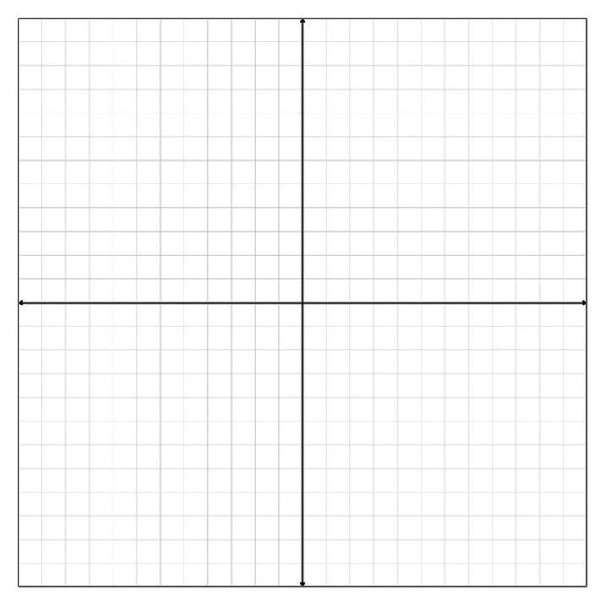
Vertex: | Max/Min | axis of symmetry
Vertex Form:

x intercept(s):

y-intercept:

 |  |  | Range | Domain:
Scratch work:

2. $y=2x^{2}+4x-4$ |  | opens up or down? | 
Vertex: | Max/Min | axis of symmetry
Vertex Form:

x intercept(s):

y-intercept:

 |  |  | Range | Domain:
Scratch work:

3. ${y=2x}^{2}-12x+10$ |  | opens up or down? | 
Vertex: | Max/Min | axis of symmetry
Vertex Form:

x intercept(s):

y-intercept:

 |  |  | Range | Domain:
Scratch work:

4. $y=3x^{2}+6x-3$ |  | opens up or down? | 
Vertex: | Max/Min | axis of symmetry
Vertex Form:

x intercept(s):

y-intercept:

 |  |  | Range | Domain:

List the transformations for the following Quadratics:
4. $f(x)=-\frac{1}{3}(x+2)^{2}-5$
_______________________________________________________________________________
5. $f(x)=4 (x-2)^{2}+17$
_______________________________________________________________________________ $6. f(x)=(3(x-7{))}^{2}-2$
_______________________________________________________________________________
7. $f(x)=\frac{1}{2}(-x+9)^{2}-4$
_______________________________________________________________________________
8. Write the equation in vertex form for the following transformations:
Up 2, left 1, stretches horizontally by 3 and reflected over the $x-axis$
________________________________________________________________________________
9. Write the equation in vertex form for the following transformations:
Left 6, stretches vertically by 2 and reflected over the $y-axis$
________________________________________________________________________________
10. Write the equation in vertex form for the following transformations:
Up 3, left 7, and reflected over the $x-axis$
________________________________________________________________________________
11. Write the equation in vertex form for the following transformations:
Down 4, right 6, stretches vertically by 0.33 and reflected over the $both the x and y-axis$
________________________________________________________________________________
12. Write the equation in vertex form for the following transformations:
Down 7, right 8, stretches horizontally by 4 and reflected over the $y-axis$
________________________________________________________________________________

